Commemorations of the Day:  Post-feast of the Holy Cross;  Commemoration of our Holy Great-Martyr Euphemia  May God Bless Our Students, Families,  Faculty, and Staff  for the  2022-2023  Academic Year  May God Grant Ukraine Peace and End to the War!  With special thanks:  Schola and Cantors  Led by Mr. Ryan Mulvey, Esq.  Pastor  Very Rev. Robert Hitchens  Parochial Vicar  Rev. Andrii Chornopyskyi  The Ukrainian Catholic National Shrine  of the Holy Family  The congregation alternates verses (beginning with the right, Christ side):  - Set a guard, O Lord, before my mouth*  and a portal around my lips.  - Incline my heart away from evil dealings,*  from finding excuses for sinful deeds.  - In company with those who work iniquity,*  let me not partake of what they choose.  - May the just chasten me with justice and reprove me;*  may the oil of the wicked never touch my head.  - Yet even then shall I pray for their welfare.*  Their rulers were swallowed near the rock.  - My words will be heard,*  for they were sweet.  - As a lump of clay broken on the ground,*  so their bones were strewn near the grave.  - To You, Lord, O Lord, my eyes are lifted up.*  In You have I hoped; let not my soul be lost.  - Keep me from the snare that was set for me,*  and from the stumbling-blocks of the wicked.  - The wicked shall fall into their own nets,*  while I remain alone until I can escape.  Psalm 141 (142)  - With my voice I cried to the Lord;*  with all my voice I implored the Lord.  - Before Him I pour out my supplications;*  before Him I declare my distress.  - When my breath was escaping me,*  then you knew my paths;  - On the road upon which I was walking,*  they set up snares for me.  - I looked to my right and observed*  there was no one friendly to me;  Page 2  From the morning watch until night*  Let Israel trust in the Lord.  By stretching forth his arms Moses vanquished Amalek, prefiguring the image of the Cross; and we now, bowing down before the tree of the Cross, trample underfoot the wiles and machinations of the enemy, having Christ as our champion, Who was lifted up upon it in the flesh, slaying the serpent and saving mankind.  For with the Lord there is mercy and with him there is plentiful redemption;*  And He shall redeem Israel from all its iniquities.  You adorned yourself with the beauty of purity and the blood of martyrdom, O glorious Euphemia, and made a gift of yourself to your Creator, who keeps you in incorruption forever. Now you rejoice with the hosts of angels and archangels, and with the choirs of apostles, prophets, and martyrs.  Psalm 116 (117)  Praise the Lord, all you nations*  Proclaim His glory, all you people.  Tormented by the wheel, wild beast, fire and water, you were strengthened in y hour endurance by the Holy Spirit. You drowned the Prince of darkness in the rush of your blood as you crossed over to the heavenly dwelling-places, bringing martyrdom to your Bridegroom O virgin martyr Euphemia, as your marriage dowry.  Strong is the love of the Lord for us;*  Eternally will His truth endure.  O holy martyr, in dying, you poured out your blood as a stream of life to the praise of the Lord. With it, you refreshed the faithful, enlightening them with the knowledge of God, as you drowned in its flow the enemies of the Faith. Thus, the Council documents were entrusted to your keeping, and you strengthened the dogmas of the Church for all ages.  Glory be to the Father and to the Son*  And to the Holy Spirit.  Page 4  Svitlo Tykhe (Tranquil Light)  Tranquil Light,  of the holy glory of the immortal, heavenly,  holy, blessed Father, O Jesus Christ:  as we come upon the sunset,  as we see the evening light,  we sing to God, the Father, the Son, and the Holy Spirit.  At all times You are worthy of being hymned by joyful voices;  O Son of God, You are the Giver of Life.  For this the whole world glorifies You!  Evening Prokeimenon  (Tone 6)  The Evening Prokeimenon: My Help comes from the Lord,*  Who made both heaven and earth (Psalm 120).  My Help comes from the Lord,*  Who made both heaven and earth.  I have lifted up my eyes to the mountains,*  from where shall come my help.  My Help comes from the Lord,*  Who made both heaven and earth.  The Lord will guard you from evil,*  He will guard your soul.  My Help comes from the Lord,*  Who made both heaven and earth.  My Help comes from the Lord,*  Who made both heaven and earth.  Reading Exodus 15:22-16:1  Homily Very Rev. Dr. Mark Morozowich Dean of the School of Theology and Religious Studies  Page 6  Response to doxology (“...now and forever and ever”):  Peace be to all.  asd  Bow your heads to the Lord.  O Lord our God, who bowed the heavens and came down for the salvation of the human race, look upon Your servants and upon Your inheritance, for to You, the Awesome Judge who love mankind, Your servants have bowed their heads and inclined their necks, not waiting for any human help, but awaiting your mercy and looking for your salvation. Guard them at every moment, during both the present evening and the approaching night, from every foe, from every hostile operation of the devil and from vain thoughts and evil desires. Blessed and glorified be the might of Your kingdom, of the + Father and of the Son and of the Holy Spirit, now and for ever and ever.  The Canticle of Symeon  (Luke 2:29-32)  Now, O Master, You have kept your promise; let your servant go in peace.  With my own eyes I have seen the salvation  which you have prepared in the sight of every people.  A light to reveal you to the Gentiles and the glory of your people Israel.  Schola: Troparion of the Cross  Save Your people, O Lord, and bless Your inheritance. Grant victory to Your faithful people against enemies, and protect Your community by Your Cross.  Page 8 | 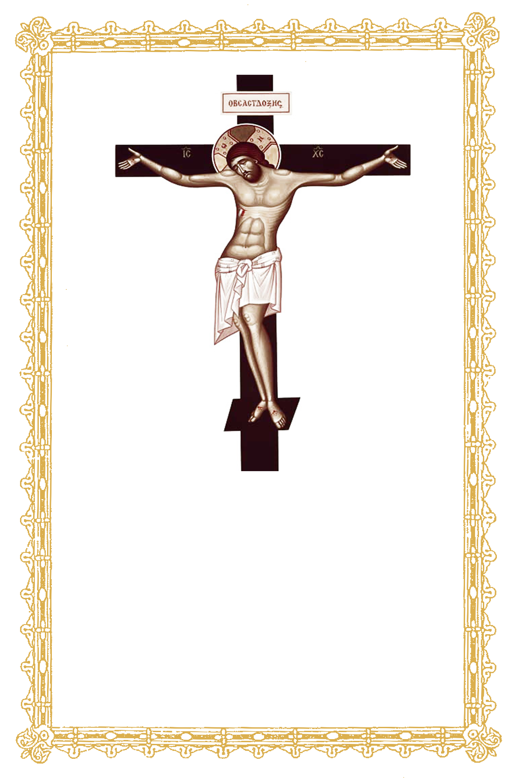  Dean’s Vespers  Post-feast of the Holy Cross  Thursday, September 15, 2022  School of Theology and Religious Studies  Schola: Opening Hymn  Ps 103(4)  Opening Blessing  Master, give us the blessing.  ✝ Blessed is our God, always, now and forever and ever.  The congregation alternates the psalm verses (beginning with the right, Christ side):  - ✝ Come, let us worship and fall down before the King, our God.  - ✝ Come, let us worship and fall down before Christ the King, our God.  - ✝ Come, let us worship and fall down before Christ Himself, our King and God!  Schola: The Lamp-Lighting Psalms  Psalm 140 (141)  O Lord, I have cried to You, hear me;  hear me, O Lord!  O Lord, I have cried to You, hear me;  receive the voice of my prayer  when I call upon You.  Hear me, O Lord!  Let my prayer rise like incense before You;  and the lifting up of my hands as an evening sacrifice.  Hear me, O Lord!  Page 1  - Even flight was denied me;*  there was no one to take care of my life.  - I cried out to You , O Lord, and said:*  You are my hope, my share in the land of the living.  - Listen to my supplication,*  for I am laid very low.  - Deliver me from my oppressors;*  for they have overwhelmed me.  - Lead my soul forth from prison*  that I may give thanks to your name.  - The just shall gather around me*  when You have been good to me.  Psalm 129 (130)  - Out of the depths I cry to You, O Lord,*  O Lord, hear my voice!  - Let Your ears be attentive*  to the voice of my prayer.  If You mark iniquities, O Lord, who can stand?*  But with You forgiveness is that You may be revered.  The Schola sings the stichera  Today Your precious Cross has shone forth radiantly like the sun, O Savior Christ, set up and elevated on the most glorious place of the skull, on Your most holy mountain, showing forth most manifestly that it is thereby, O Omnipotent One, that You have raised our nature up to the heavens, in that You are the Lover of mankind.  I have waited for You as you have commanded;*  My soul patiently relies on Your promise, for it has trusted in the Lord.  Today, O Unapproachable One, the heavens have declared Your glory unto mankind; for the image of the Cross, shining forth in radiance with unapproachable light, has denounced the savage and cruel nature of those who slew God. Wherefore, we glorify Your loving dispensation, O almighty Jesus, Savior of our souls.  Page 3  O Christ our God, Moses prefigured the salutary effects of Your precious Cross when he defeated the mighty Amalek in the desert of Sinai, for while he extended his arms crosswise, the people were victorious. All these symbols have now attained their perfection before our eyes: today the whole creation is delivered from corruption, for all blessings have been bestowed upon us by the Cross. Wherefore, we joyfully kneel to You and say, “How great are Your works, O Lord! Glory to You!”  Now and Forever*  And Ever. Amen.  Divine treasure hidden in the earth, the Cross of the Giver of Life appeared in the heavens to the pious King, and its inscription spiritually signified his victory over the enemy. Rejoicing with faith and love, inspired by God, he made haste to raise on high the Cross which he had seen in his vision; and with great zeal he brought it forth from the bosom of the earth, for the deliverance of the world and the salvation of our souls.  Entrance  Let us pray to the Lord.  At evening, at morning and at midday we praise, bless and give thanks, and we pray to You, Master of all things, Lord who love mankind: Direct our prayer before You like incense, and do not incline our hearts to words or thoughts of evil, but deliver us from all that hunt down our souls. For our eyes look to You, O Lord, our Lord, and we have hoped in You. For to You belong all glory, honor and worship, to the + Father, the Son and the Holy Spirit, now and for ever and ever  Master, bless the holy entrance.  Blessed is the entrance of Your holy ones, always, now and for ever and ever.  Amen. ✝ Wisdom, stand aright!  Page 5  Schola: Kataxiosin  (Sung in Ukrainian)  Make us worthy, O Lord, to be kept sinless this evening.  ✝ Blessed are You, O Lord, the God of our fathers, and praiseworthy and glorious is Your Name forever. Amen.  May Your mercy, O Lord, be upon us who have placed our hope in You.  ✝ Blessed are you, O Lord, teach me Your commandments.  ✝ Blessed are You, O Master, make me understand Your commandments.  ✝ Blessed are You, O Holy One, enlighten me with Your commandments.  O Lord, Your mercy endures forever, despise not the work of Your hands.  To You is due praise, to You is due a hymn,  To You is glory due, ✝ Father, Son, and Holy spirit, now and forever and ever. Amen.  Petitions  Response to first petitions (except those ending “Let us ask the Lord…”):  Response to petitions ending “Let us ask the Lord”:  Response to final petition (“Let us commend ourselves and one another…”):  Page 7  Final Blessing and Dismissal  Wisdom!  More honorable than the cherubim,* and by far more glorious than the seraphim,* ever a virgin, you gave birth to God the Word,* O true Mother of God, we magnify you.  ✝ Glory be to You, Christ our God and our hope, glory be to You!  ✝ Glory be to the Father, and to the Son, and to the Holy Spirit,* now and forever and ever. Amen.* Lord have mercy, Lord have mercy, Lord have mercy.* Give the blessing!  ✝ Christ our true God, through the prayers of His most pure mother, by the power of the Precious and Life-Giving Cross, of the Holy Great-Martyr Euphemia, whose memories we commemorate this day, and of the Holy Family, who protects this faith community, will have mercy on us and save us, for He is good and loves mankind.  asdgasdgasgd  Prostration Hymn  To Your cross, O Master, we bow in veneration, and we glorify Your holy resurrection.  To Your cross, O Master, we bow in veneration, and we glorify Your holy resurrection.  To Your cross, O Master, we bow in veneration.  And we glorify Your holy resurrection.  Postlude: Under Your Patronage  (Sung in Church Slavonic)  Under your patronage we fly, O Virgin Mother of God; do not despise our prayers in our afflictions, but deliver us from our miseries, you who alone are pure and blessed. Most Holy Mother of God, save us!  Page 9

